EXP NO 6. Demonstrate virtualization by Installing Type-2 Hypervisor in your device, create and configure VM image with a Host Operating system (Either Windows/Linux) using
virtual box.

DATE:
AIM:
To demonstrate virtualization by installing a Type-2 Hypervisor (VirtualBox) in the device, and create and configure a Virtual Machine (VM) image with a host operating system (either Windows/Linux).
PROCEDURE:
STEP 1: install Oracle VirtualBox as a Type-2 Hypervisor
STEP 2: Download an ISO image file of the operating system (Ubuntu Linux / Windows). STEP 3: Open VirtualBox → Click New → Create a new Virtual Machine.
STEP 4: Configure the VM
STEP 5: Start the Virtual Machine → The system will boot from the ISO file.
STEP 6: Install the selected operating system (Linux/Windows) by following the on-screen setup instructions.
STEP 7: After successful installation, launch the VM → The guest operating system runs inside VirtualBox.
Design:
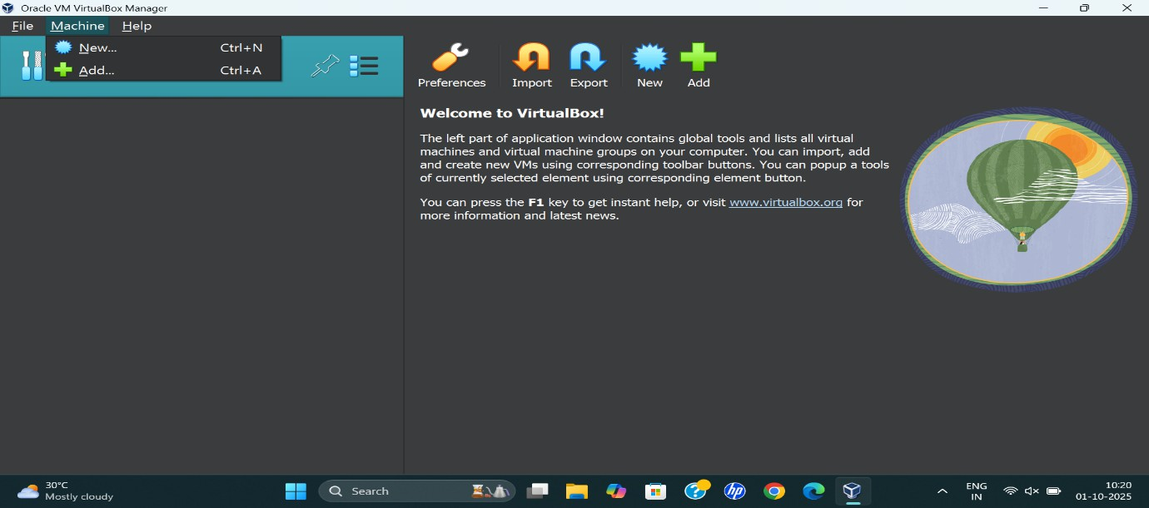

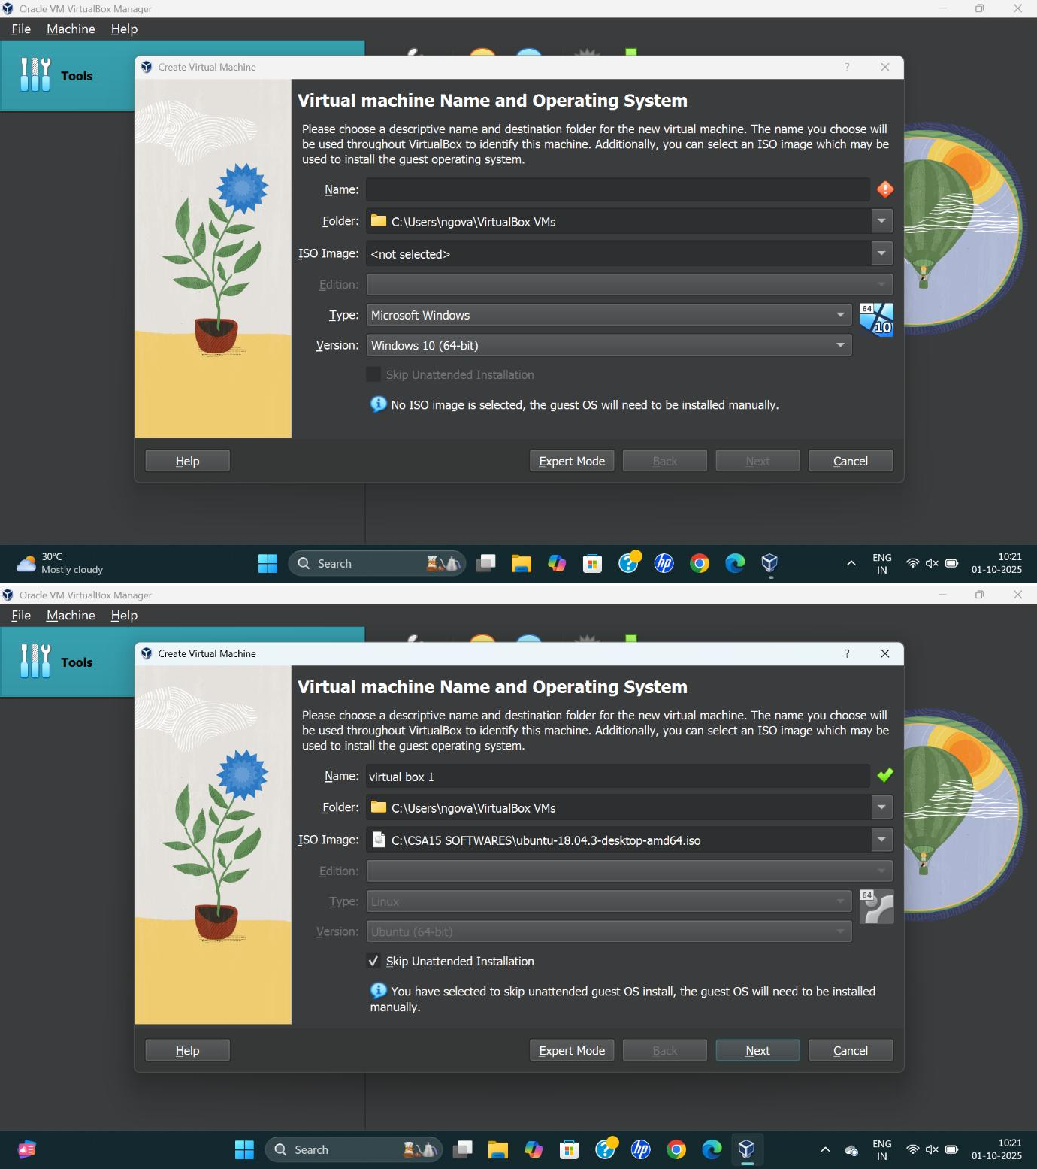

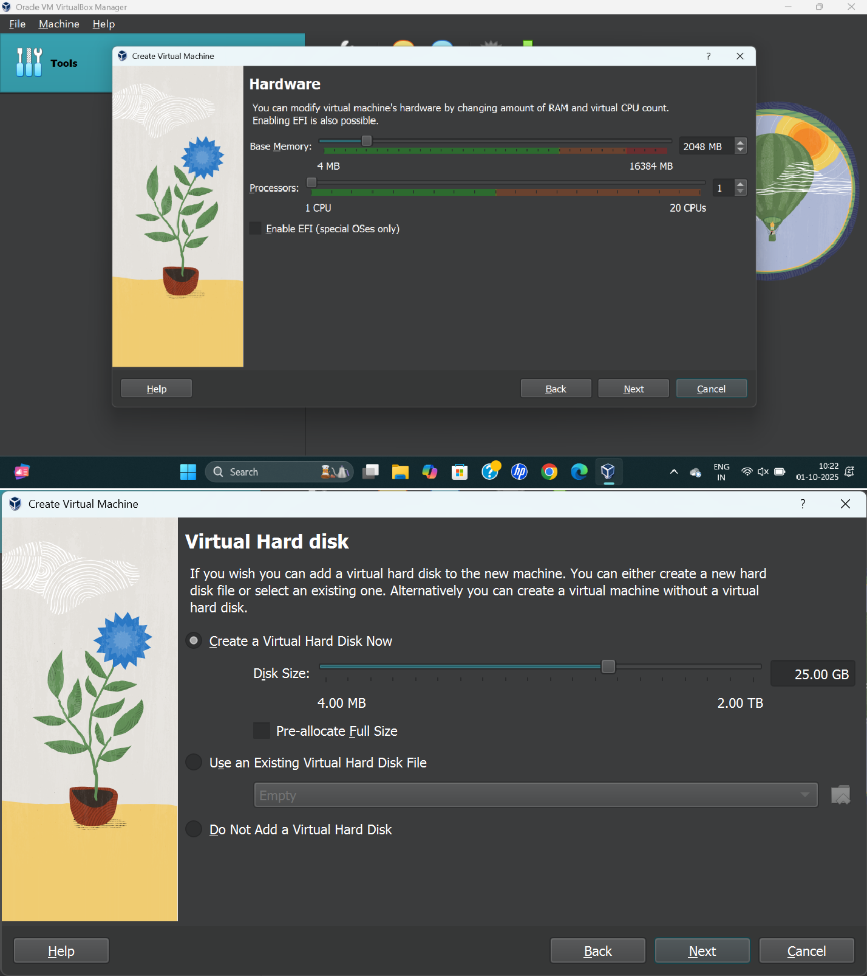

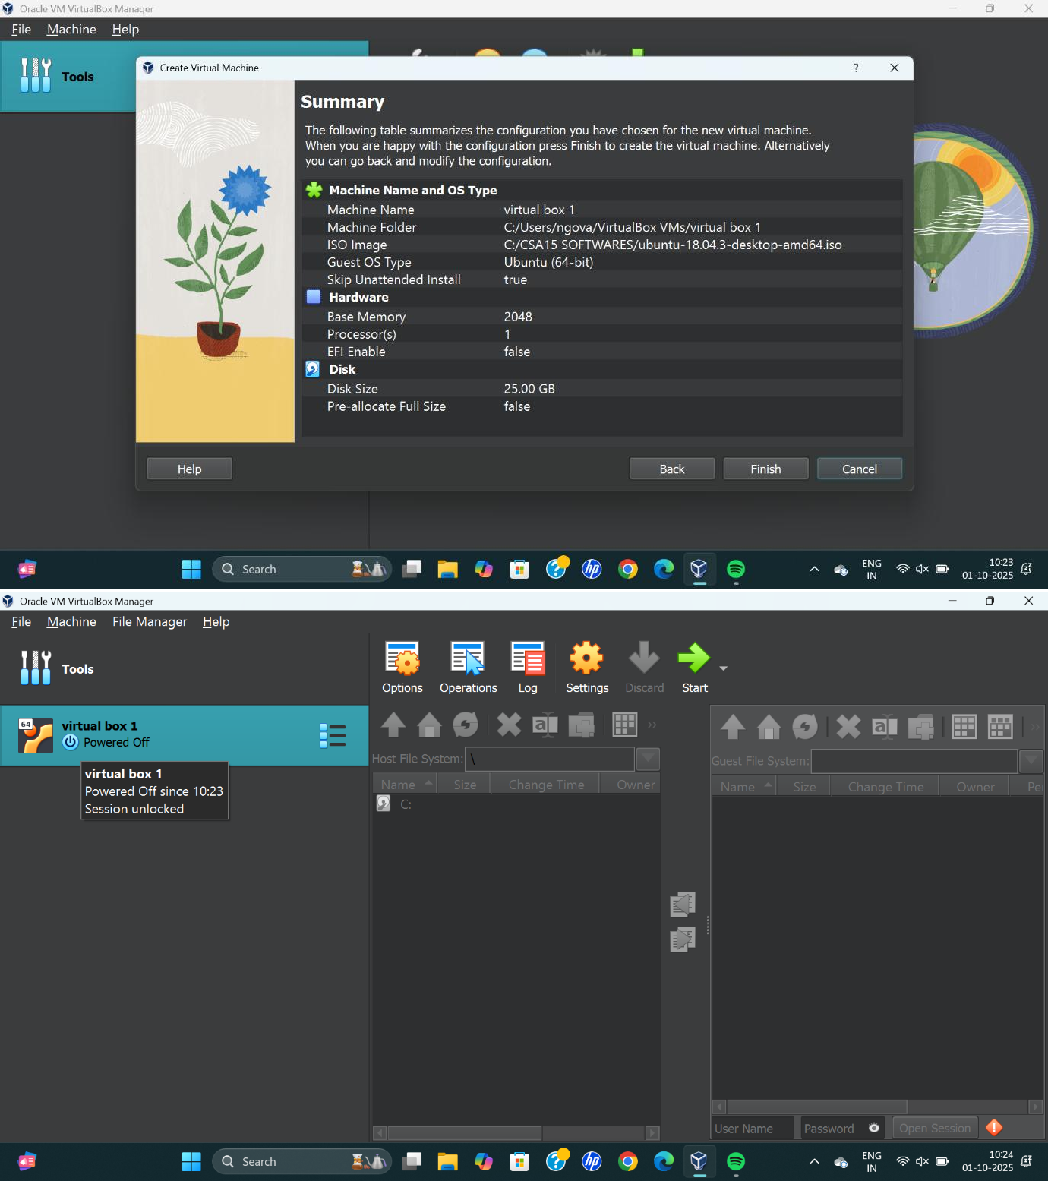

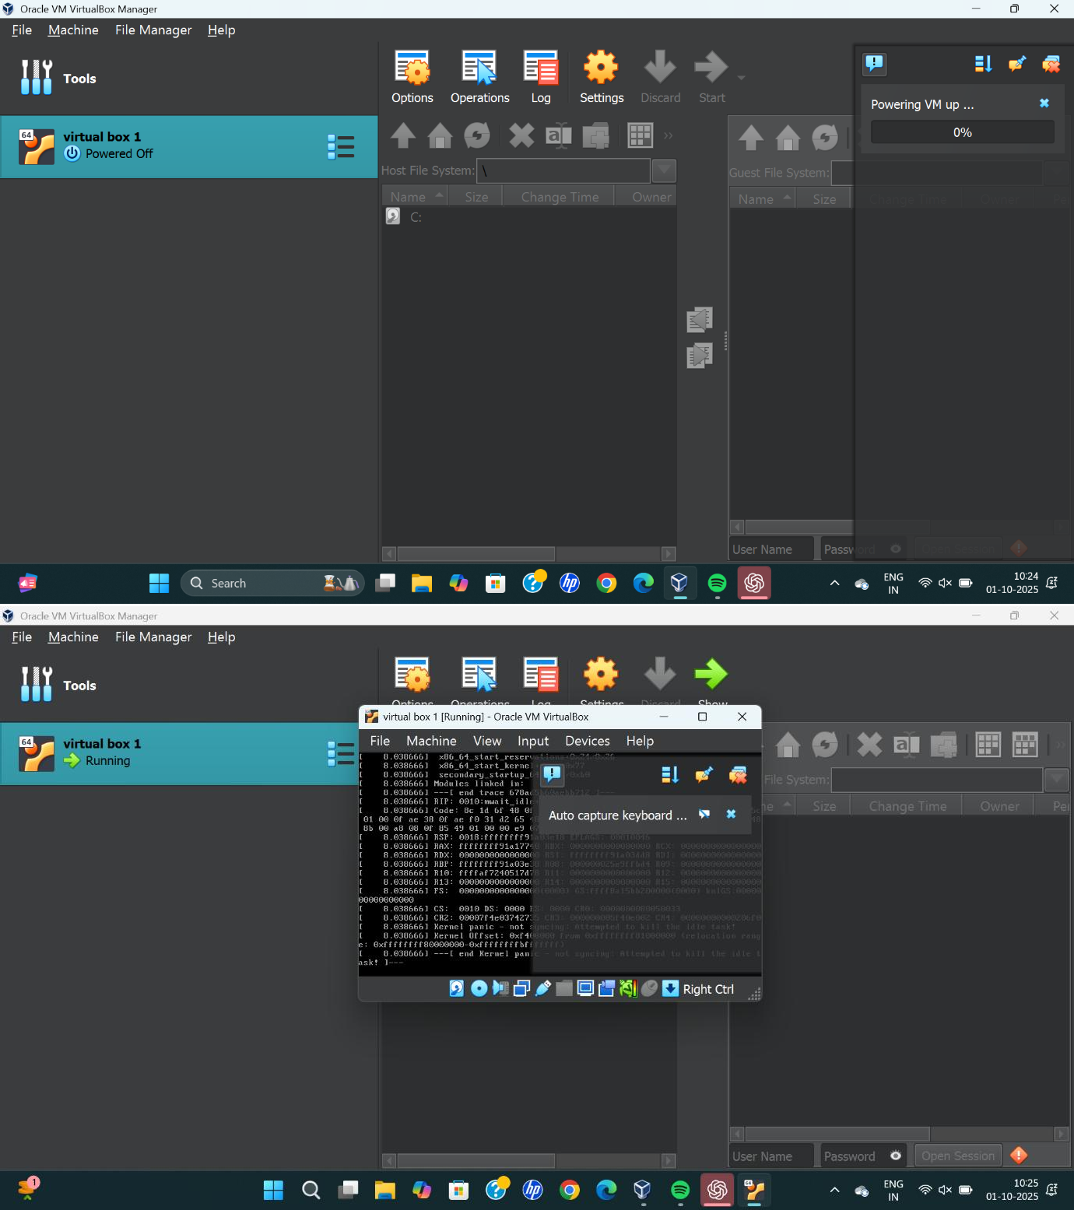

RESULT:
Virtualization was successfully demonstrated using Oracle VirtualBox (Type-2 Hypervisor) by creating and configuring a Virtual Machine with an operating system.

